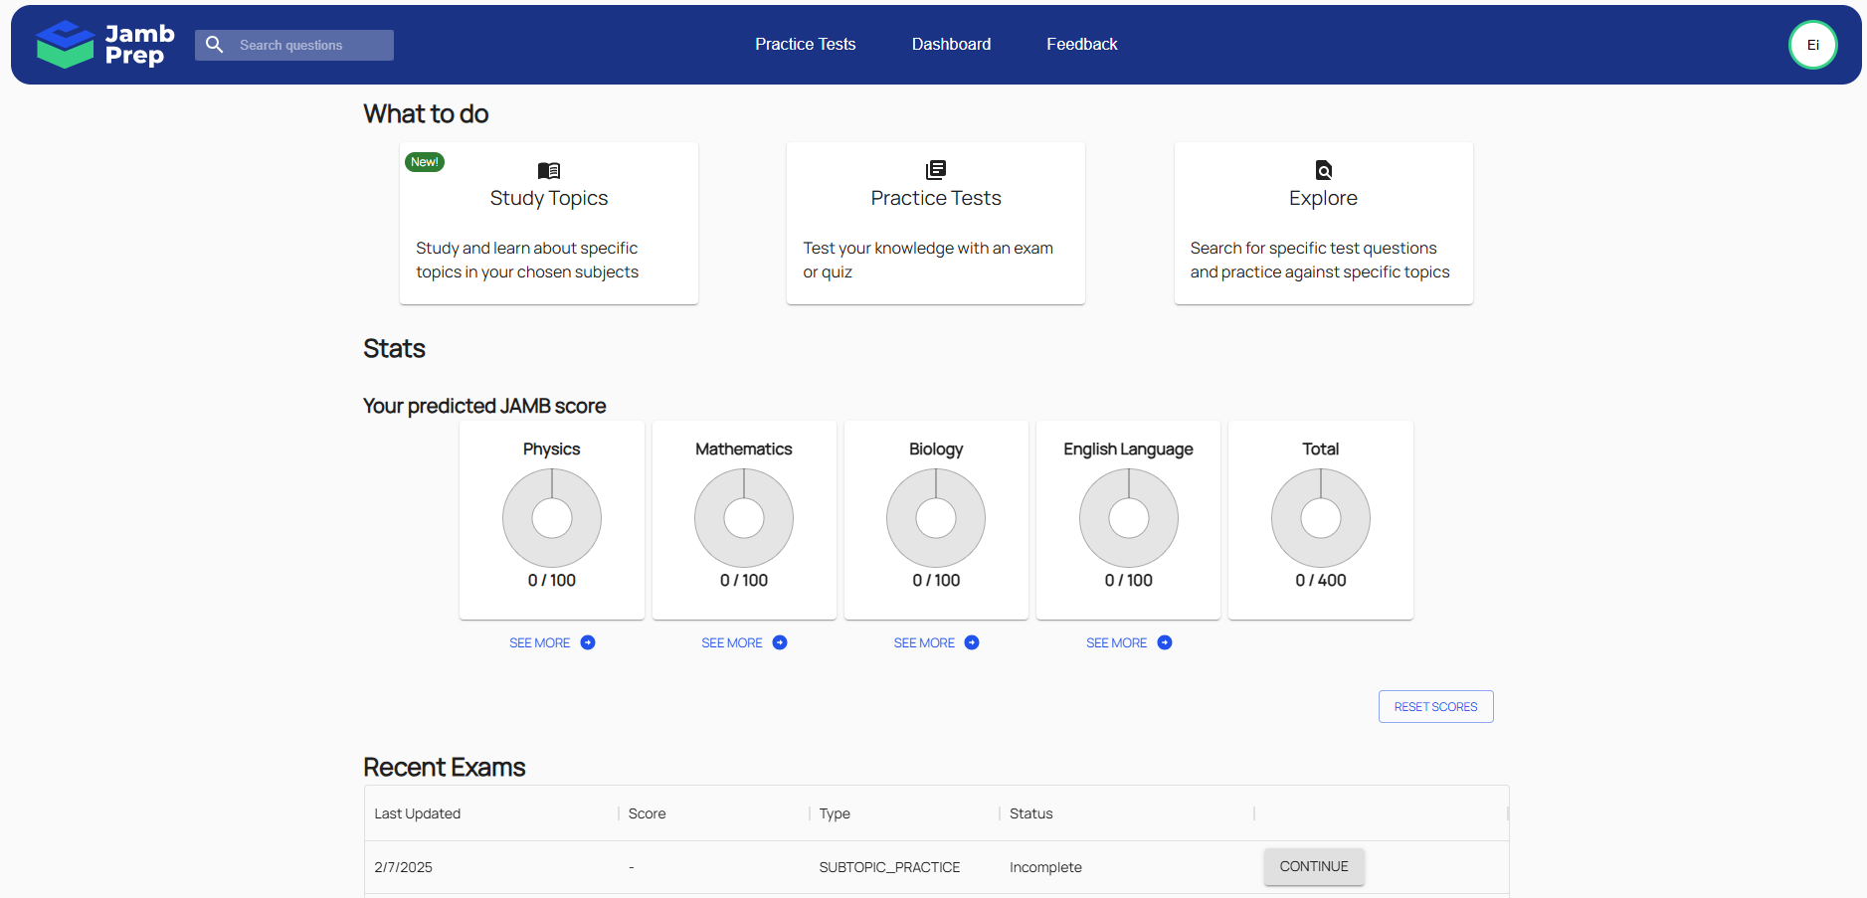

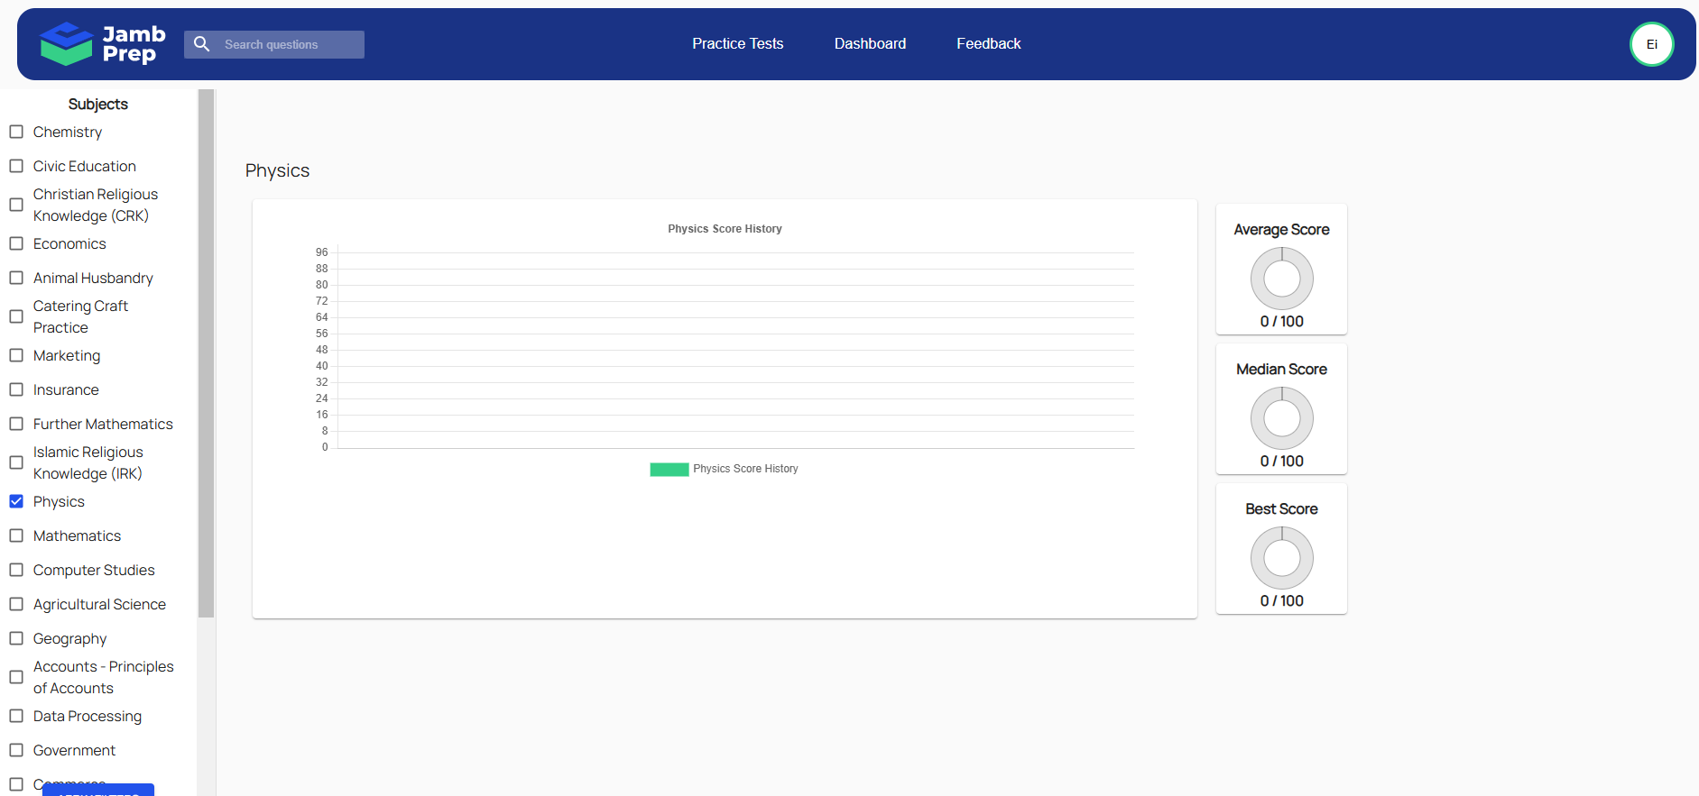

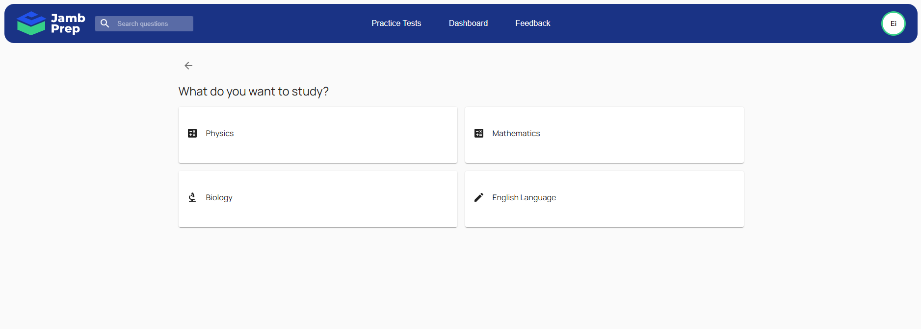

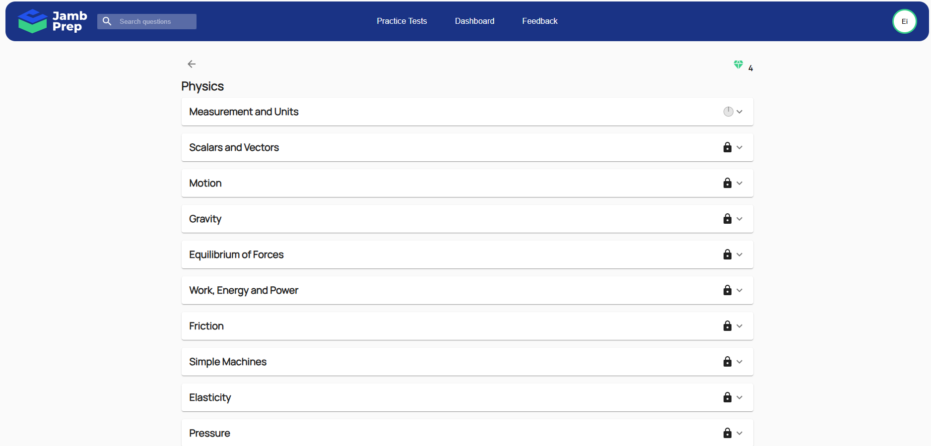

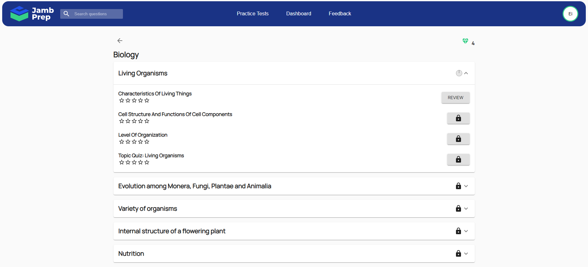

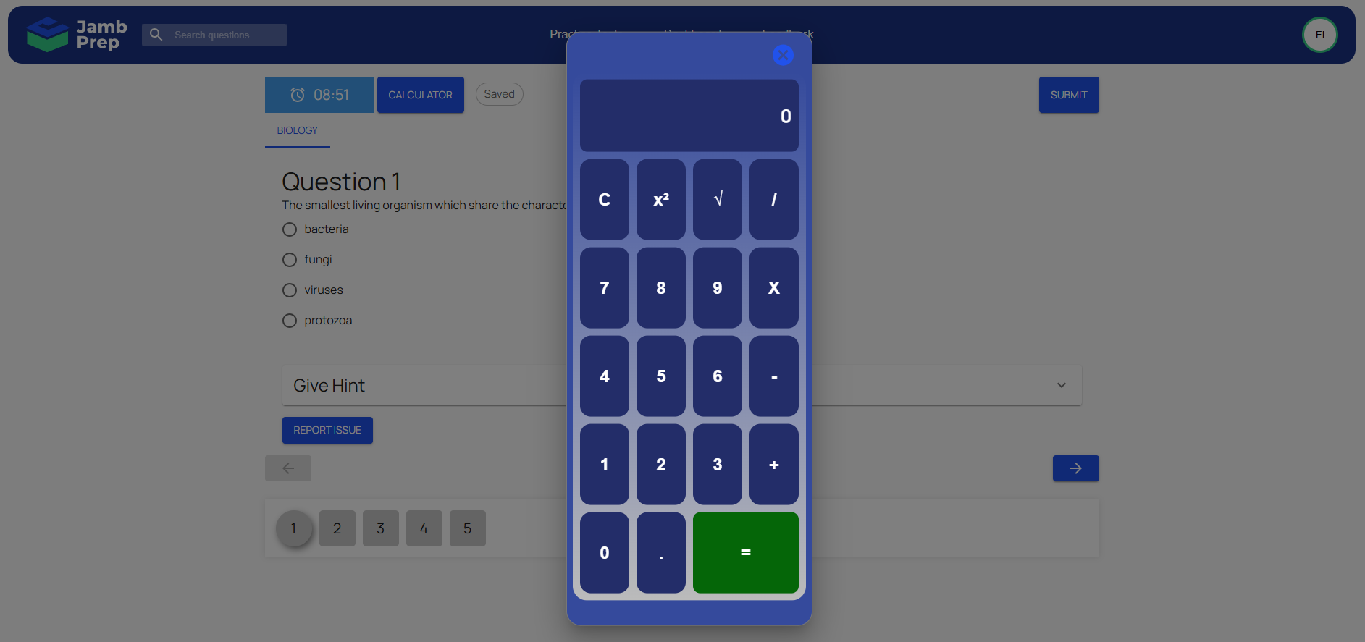

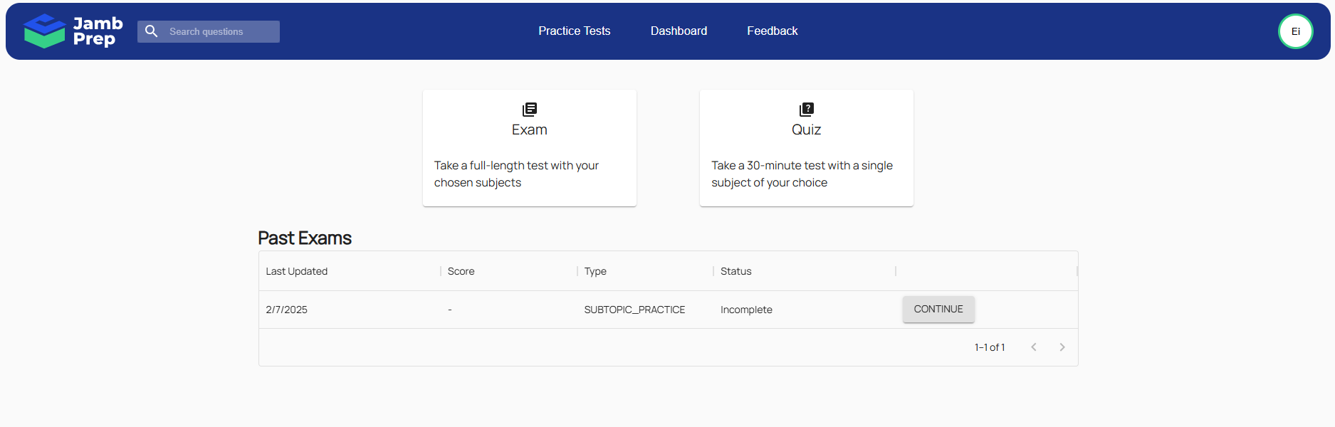

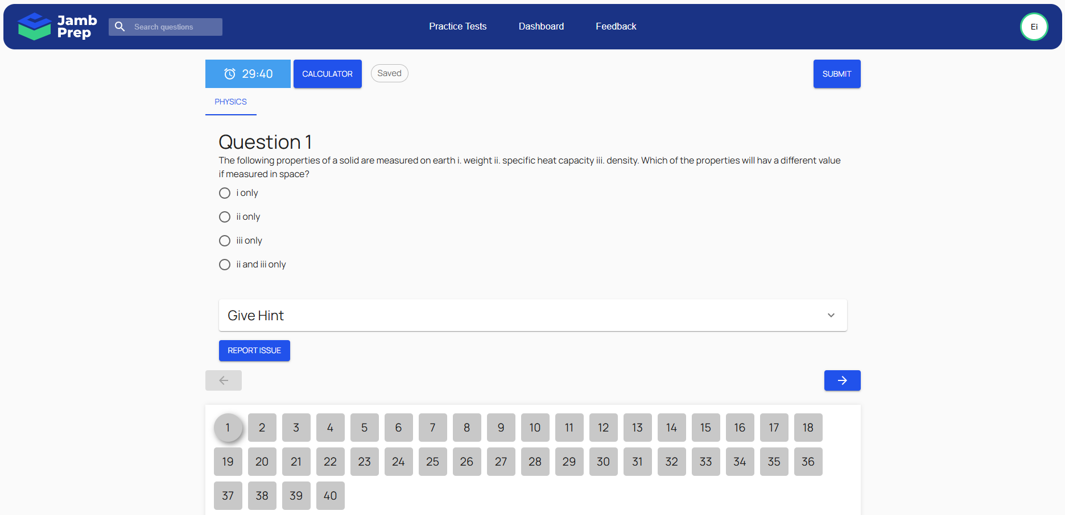

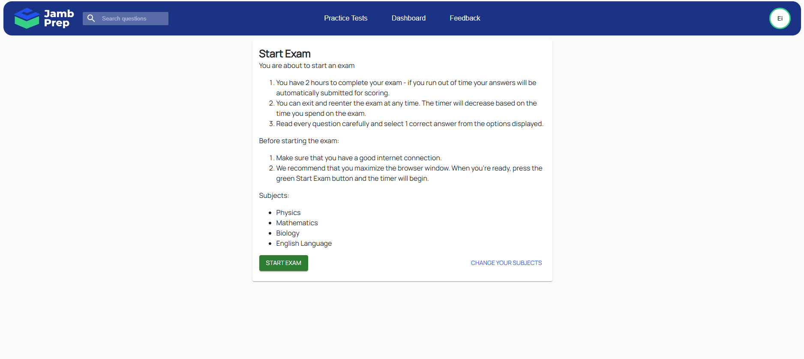

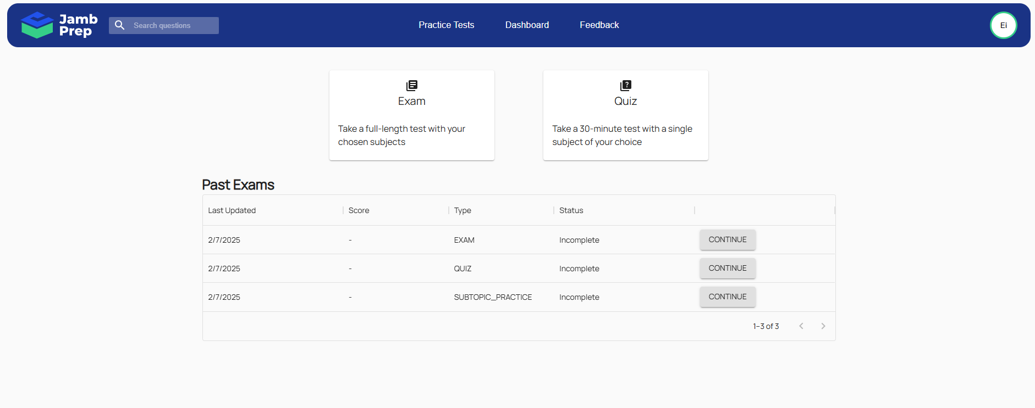

There is this exam in Nigeria called Jamb. I want to build a mobile app with flutter using FastAPI. User take quizzes based on the selected subjects. Questions belong to Section; Sections belong to Subject. User dashboard showing the performance statistics of the selected subjects by user. User can access the study area for each selected subjects. The study area of each subject will be display based on section. User can access the quiz area for each selected subjects. The quiz area of each subject will be display based on section. User can access the Exam area for each selected subjects. The Exam area will be the combine quizzes of the sections for that particular subject.

Every quiz and exam has points depending on the percentage scores. Cumulative points of each users will be calculated and be displayed on a leaderboard.

User should be able to rate each section, this will help other users to know most asked questions.

Each subject is to be paid for, and the subscription period can varies.

The Question page for the quiz or exam will have the question, options, arrays of number buttons showing the number of questions to answer, a calculation, a timer.